- \Operation\Basic settings\Reference offset values
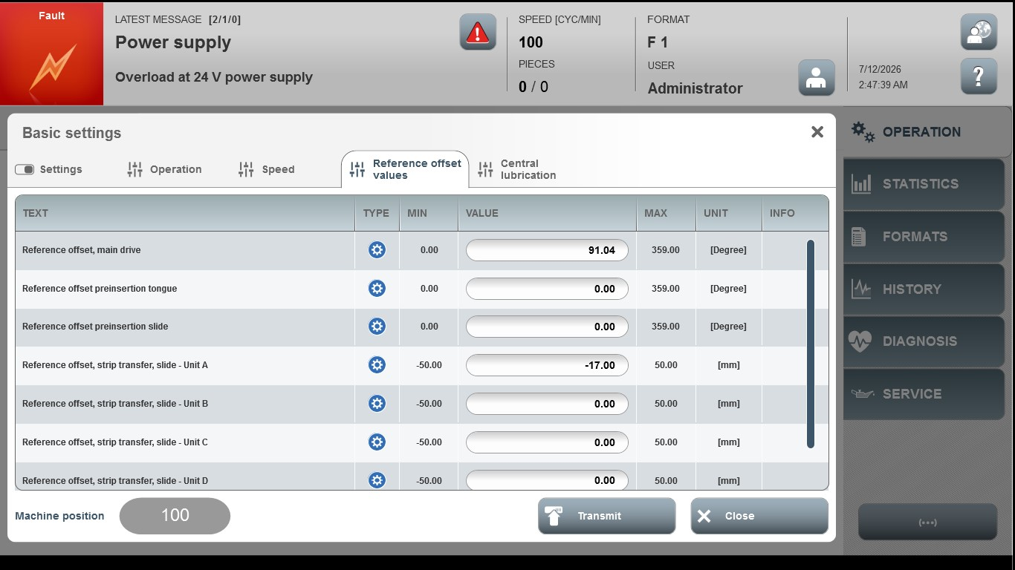
Acceptance criterion | Limits | Pass / Fail: Dev-No. | Date | Initials
Screen matches screenshot | N / A
Reference offset, main drive | 0.00 ... 359.00
Reference offset preinsertion tongue | 0 ... 359
Reference offset preinsertion slide | 0 ... 359
Reference offset , strip transfer slide A | -50.00 ... 50.00
Reference offset , strip transfer slide B | -50.00 ... 50.00
Reference offset , strip transfer slide C | -50.00 ... 50.00
Reference offset , strip transfer slide D | -50.00 ... 50.00

